PROMISE & PRACTICE · GROWTH & CONFLICT · SOURCE ANALYSIS
The War from the North
Same war, two stories
Name: ______________________________ Period: _____ Date: ________________
WHAT I CAN DO TODAY I can read primary sources about The War from the North, weigh who made each one and why, and use evidence to answer historical questions.
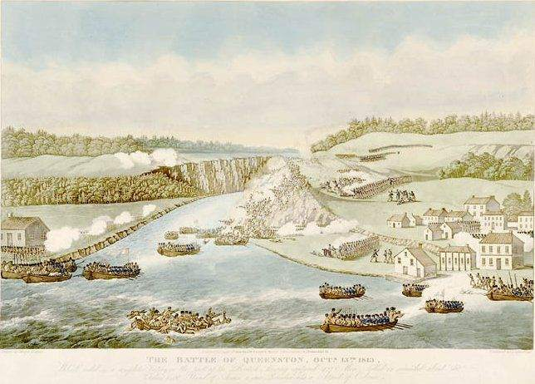
The Battle of Queenston Heights, 13 October 1812 — a British, Canadian, and Mohawk victory on the Niagara frontier. Period illustration, public domain (source to confirm).

THE SOURCES
THE AMERICAN MEMORY
A “second war of independence.” A young republic stands up to the British Empire, holds Baltimore, and watches its flag survive the night — the image that became the national anthem. The border holds; national pride is born
How the war is widely remembered in the United States.
THE CANADIAN MEMORY
An invasion turned back. Brock and Tecumseh take Detroit; the militia and Mohawk allies hold Queenston Heights; Laura Secord makes her walk; Montreal is saved. British North America survives and begins to feel like a nation of its own — “the war that made Canada.”
How the war is widely remembered in Canada.
THE INDIGENOUS MEMORY
A fight for the land itself — and a disaster. Tecumseh’s confederacy is destroyed and he is killed; at the peace table in Ghent the British drop their Indigenous allies entirely. The one power that might have held back American settlement is gone, and the road to removal lies open
How the war is remembered by many Indigenous nations.

YOUR WORK
A. PICK TWO OF THE THREE MEMORIES ABOVE. FOR EACH, WHO WOULD MOST WANT THE STORY TOLD THIS WAY — AND WHAT DO THEY WANT YOU TO FEEL?
a. Pick two of the three memories above. For each, who would most want the story told this way — and what do they want you to feel?
____________________________________________________________________________________________
____________________________________________________________________________________________
____________________________________________________________________________________________
B. ALL THREE DESCRIBE THE SAME WAR. WHY CAN THREE TRUE-SOUNDING STORIES DISAGREE SO COMPLETELY ABOUT WHAT THE WAR WAS?
b. All three describe the same war. Why can three true-sounding stories disagree so completely about what the war was?
____________________________________________________________________________________________
____________________________________________________________________________________________
____________________________________________________________________________________________
____________________________________________________________________________________________
A. TAKE ONE EVENT FROM THE PRESENTATION — DETROIT, QUEENSTON HEIGHTS, OR BEAVER DAMS. WHO IS THE HERO IN THE CANADIAN TELLING? WHO DID MUCH OF THE FIGHTING BUT IS BARELY NAMED?
a. Take one event from the presentation — Detroit, Queenston Heights, or Beaver Dams. Who is the hero in the Canadian telling? Who did much of the fighting but is barely named?
____________________________________________________________________________________________
____________________________________________________________________________________________
____________________________________________________________________________________________
____________________________________________________________________________________________
B. THE “MILITIA MYTH” MADE ORDINARY CANADIAN SETTLERS THE HEROES OF 1812. WHO DOES THAT VERSION LEAVE OUT, AND WHY MIGHT A NEW COUNTRY PREFER IT?
b. The “militia myth” made ordinary Canadian settlers the heroes of 1812. Who does that version leave out, and why might a new country prefer it?
____________________________________________________________________________________________
____________________________________________________________________________________________
____________________________________________________________________________________________
____________________________________________________________________________________________
NAME ONE HARD FACT ABOUT THE WAR THAT ALL THREE MEMORIES WOULD HAVE TO AGREE ON — THEN ONE THING THEY FLATLY DISAGREE ABOUT. WHAT MAKES THE FIRST KIND OF CLAIM DIFFERENT FROM THE SECOND?
Name one hard fact about the war that all three memories would have to agree on — then one thing they flatly disagree about. What makes the first kind of claim different from the second?
____________________________________________________________________________________________
____________________________________________________________________________________________
____________________________________________________________________________________________
____________________________________________________________________________________________
CLAIM — WHO “WON” THE WAR OF 1812? TAKE A CLEAR POSITION — AND SAY FOR WHOM.
CLAIM — Who “won” the War of 1812? Take a clear position — and say for whom.
____________________________________________________________________________________________
____________________________________________________________________________________________
____________________________________________________________________________________________
EVIDENCE — GIVE AT LEAST TWO SPECIFICS FROM THE PRESENTATION AND THE THREE SOURCES THAT SUPPORT YOUR CLAIM.
EVIDENCE — give at least two specifics from the presentation and the three sources that support your claim.
____________________________________________________________________________________________
____________________________________________________________________________________________
____________________________________________________________________________________________
____________________________________________________________________________________________
REASONING — THE BORDER DIDN’T MOVE AN INCH, YET THREE PEOPLES REMEMBER THREE DIFFERENT OUTCOMES. WHAT DOES THAT TELL YOU ABOUT THE DIFFERENCE BETWEEN WHAT HAPPENED AND HOW IT IS REMEMBERED?
REASONING — the border didn’t move an inch, yet three peoples remember three different outcomes. What does that tell you about the difference between what happened and how it is remembered?
____________________________________________________________________________________________
____________________________________________________________________________________________
____________________________________________________________________________________________
____________________________________________________________________________________________
Promise & Practice · ShadowDog Digital Studios · Unit 2

TEACHER ANSWER KEY — The War from the North

a. Pick two of the three memories above. For each, who would most want the story told this way — and what do they want you to feel?: Open response.
b. All three describe the same war. Why can three true-sounding stories disagree so completely about what the war was?: Open response.
a. Take one event from the presentation — Detroit, Queenston Heights, or Beaver Dams. Who is the hero in the Canadian telling? Who did much of the fighting but is barely named?: Open response.
b. The “militia myth” made ordinary Canadian settlers the heroes of 1812. Who does that version leave out, and why might a new country prefer it?: Open response.
Name one hard fact about the war that all three memories would have to agree on — then one thing they flatly disagree about. What makes the first kind of claim different from the second?: Open response.
CLAIM — Who “won” the War of 1812? Take a clear position — and say for whom.: Open response.
Look for a response along the lines of: “The real winner of the war was… because…”
EVIDENCE — give at least two specifics from the presentation and the three sources that support your claim.: Open response.
REASONING — the border didn’t move an inch, yet three peoples remember three different outcomes. What does that tell you about the difference between what happened and how it is remembered?: Open response.

